1. 24. setLosslessAdmin  
   0x611980Ea951D956Bd04C39A5A176EaB35EB93982
2. 25. setLosslessController  
   0xe91D7cEBcE484070fc70777cB04F7e2EfAe31DB4 (ETH MAINNET)

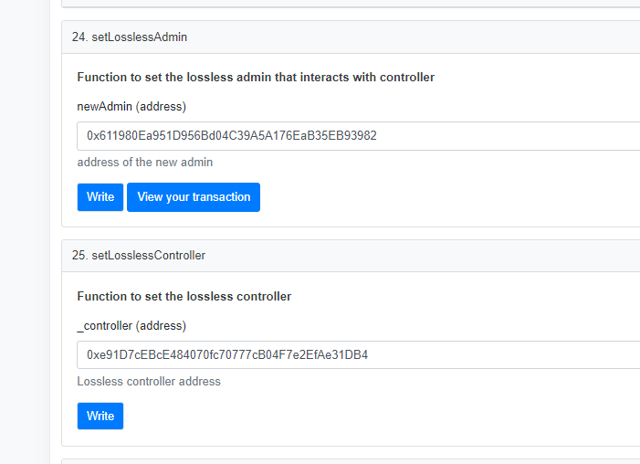

1. Add Supply  
   <https://etherscan.io/tx/0xf1b2de19a55e6c10b11d5565b8c1e1d74d43dea0ec65f75d367889129d7c9d07>
2. Remove LP  
   <https://etherscan.io/tx/0x2f5eab9bde3020257a95789c12d3c7f70cd19af9423288c905a5a4a20549e2ca>
3. Buy tokens  
   <https://etherscan.io/tx/0x1426ded8a1fd91704a3c4eb267ab43acc0945df9adfd64a490cdb240ae94de4d>
4. Sell tokens
5. Change marketingFee and test
6. Change gasFee and test
7. Change antiquitiesFee and test
8. Change reflections and test
9. Change fees wallet and test
10. transferOwnership and test
11. setMarketingWallet and test
12. setAntiquitiesWallet and test
13. setGasWallet and test
14. addBotWallet and test
15. removeBotWallet and test

All tests PASS.